

Topic test 1
Name: __________________________________

Chapter 5: Conditional probability

- Time allowed: 45 minutes
- CAS calculators may be used.
- Part A: 5 multiple-choice questions (5 marks)
- Part B: 5 short answer questions (29 marks)
- Part C: 2 analysis questions (22 marks)
Part A
5 multiple-choice questions
1 mark each: 5 marks
Circle the correct answer.
1 A bag of 20 apples has 4 rotten ones in it. If the first two apples taken at random from the bag are good, what is the probability that the next one will be rotten?
A
B
C
D
E 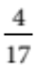

[1 mark]

2 In a certain class, students have mobile phones with the following different brands: 7 have Apples, 3 have Nokias, 6 have Samsungs, 2 have Motorolas and 4 have Sonys. What is the probability that, after class, the first three phones taken out to check for messages will all be Samsungs, assuming that they are taken out at random?
A 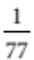
B 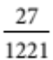
C 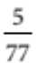
D 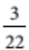
E 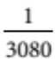

[1 mark]
3 What is the probability of getting a total of 7 twice in a row when two normal 6-sided dice are rolled?
A 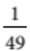
B 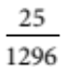
C 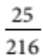
D 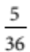
E 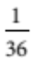

[1 mark]

4 A 420-page novel is opened to a random page by 3 different students. What is the probability that they all open it to a page number between 1 and 105?
A
B 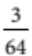
C 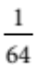
D 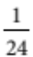
E 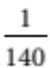

[1 mark]
5 In a particular city, about 15% of the population are left-handed and about 40% have blue eyes.
What is the probability that a person chosen at random from this group is not left-handed and does not have blue eyes?
A 6%
B 94%
C 49%
D 51%
E 65%

[1 mark]

Part B
5 short answer questions
29 marks
Show your working where appropriate.
1 Two cards are taken from a normal 52-card pack.
a Given that the first card is a spade, what is the probability that the next is also a spade?

b What is the probability that both cards are spades?

[4 marks]
2 The Beatles’ last five albums were: Sergeant Pepper’s Lonely Hearts Club Band, The White Album, Yellow Submarine, Abbey Road and Let It Be. What is the probability that three songs chosen at random from these albums are all from ‘The White Album’?

[3 marks]
3 Two sticks are taken out at random from a tube of ‘pick-up sticks’. There are 5 green, 6 red and 7 black sticks in the tube.
a What is the probability that they will both be red?

b What is the probability they will be different colours?

[6 marks]
4 The numbers of boys and girls doing some optional subjects on at the same time (on the same
line of the timetable) in Year 11 at a school are shown here.
 | Theatre | Workshop | Computer skills | History
Boys | 13 | 28 | 32 | 19
Girls | 34 | 7 | 35 | 13

a Given that a student is taking Theatre, what is the probability that the student is female?

b Given that a student is female, what is the probability that she is doing theatre?

c What is the probability that a student selected at random is a girl taking theatre?

d What is the probability that a boy on this line is in a workshop class?

[8 marks]
5 In another school, Theatre, Workshop and History are on different lines of the timetable so that a student could possibly do all 3 subjects. In a Maths class, 9 of the students take Theatre, 8 do Workshop and 8 study History. Three do Workshop and Theatre and only one student takes all three of these subjects.
5 students do History and Theatre. Altogether there are 23 students in the Maths class and 8 of these take none of Theatre, Workshop and History.
a What is the probability that if a student does theatre, they also study History?

b How many students take Workshop and history, but not Theatre?

c What is the probability that a student in this class does Workshop and History?

d What is the probability that, given a student takes History, the student also does Workshop?

[8 marks]
Part C
2 analysis questions
22 marks
Show your working where appropriate.
1 David and Elise enjoy helping their Mum make pottery mugs during the holidays, but being less experienced, they are slower and more of their mugs crack when fired. 20% of David’s and 15% of Elise’s mugs crack when fired. Only 3% of Mum’s mugs crack. At the end of the holidays, they count up the mugs that have been made. Mum has made 75%, David 10% and Elsie 15% of the mugs, including the cracked ones.
a Find the probability that a mug was both cracked and made by Elise.

b Find the probability that a mug was both cracked and made by Mum.

c Find the probability that a mug was both cracked and made by David.

d Find the probability that one of the mugs made during the holidays was cracked.

e Find the probability that a cracked mug was made by David.

f Find the probability that a cracked mug was made by Mum.

[12 marks]
2 The table below shows the reported weekly amount of time spent on homework by some students in different years at school.
 | 0–3 hours | 4–6 hours | 7–9 hours | 10–12 hours
Year 9 | 9 | 8 | 3 | 4
Year 10 | 12 | 14 | 1 | 2
Year 11 | 5 | 4 | 5 | 8
Year 12 | 6 | 5 | 4 | 4
Assume that this sample of students is typical of Australian students. Almost everybody completes
Year 10, but only about 89% and 74% complete Years 11 and 12 respectively. There are about the same number of students in each of the age groups for Years 9 to 12.
a What is the probability that if a student is in Year 12 they will spend 10–12 hours on homework?

b What is the probability that a student who spends more than 6 hours on homework is in Year 12?

c What is the probability that a student spends more than 6 hours on homework?

d Is homework time independent of grade? Explain your answer.

[10 marks]
Total marks: 56

Answers
Part A [1 mark each]
1 There are 18 left, of which 4 are rotten, so P(Next rotten) 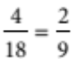
∴ D [1 mark]
2 P(3 Samsungs)  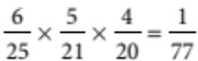
∴ A [1 mark]
3 There are 6 out 36 ways to get a total of 7, so P(total 7)  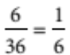
The rolls are independent so P(2 totals of 7)  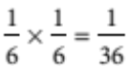
∴ E [1 mark]
4 The probability of a page between 1 and 105  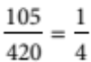.
The students open the books independently, so P(3 up to 105)  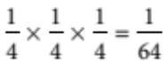
∴ C [1 mark]
5 Since blue eyes and left-handedness are independent,
P(blue eyes and left-handed)  0.15  0.4  0.06  6%
P (blue eyes or left-handed)  15%  40%  6%  49%
P(not left-handed and not blue eyes)  100%  49%  51%
∴ D [1 mark]
Part B
1 a P(2nd spade | 1st spade)  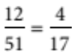 [2 marks]
b P(2 spades)  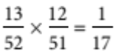 [2 marks]
[4 marks]
2 They are independent, so P(3 White album)  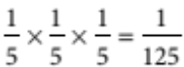 [3 marks]
3 a P(both red)  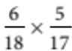
 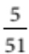 [2 marks]
b P(both green)  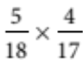
 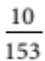

P(both black)  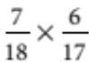
 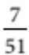
P(different colours)  1  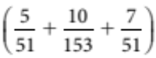
 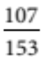 [4 marks]
[6 marks]
4 a P(female | Theatre)  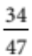 [2 marks]
b P(Theatre | female)  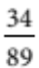 [2 marks]
c P(Theatre and female)  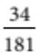 [2 marks]
d P(Workshop | male)  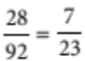 [2 marks]
[8 marks]
5 Venn diagram is:
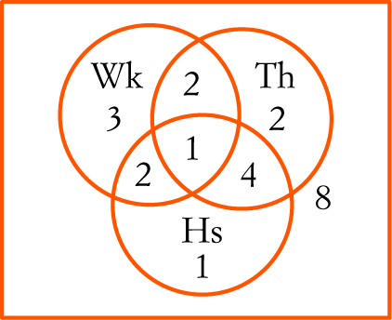
a P(History | theatre)  [2 marks]
b 2 [2 marks]
c P(Workshop and History)  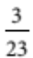 [2 marks]
d P(Workshop | History)  [2 marks]
[8 marks]
Part C
1 a P(Cracked and Elise)  0.15  0.15  0.0225 [2 marks]
b P(Cracked and Mum)  0.75  0.03  0.0225 [2 marks]
c P(Cracked and David)  0.2  0.1  0.02 [2 marks]
d P(Cracked)  0.0225  0.0225  0.2  0.065 [2 marks]
e P(David | cracked)  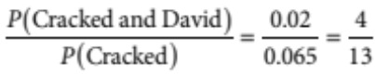 ≈ 0.308 [2 marks]
f P(Mum | cracked)  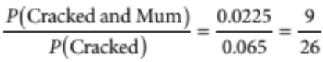 ≈ 0.346 [2 marks]
[12 marks]
2 a P(More than 6 hours | Year 12)  ≈ 0.421 [2 marks]
b P(Year 12 | More than 6 hours)  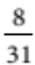 ≈ 0.258 [2 marks]
c P(More than 6 hours)  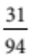 ≈ 0.330 [2 marks]
d P(More than 6 hours | Year 12) and P(Year 12 | More than 6 hours) are both different to P(More than
6 hours). Either of these alone would mean that homework is not independent of grade. It appears that Year 12 students are likely to spend more time on homework. [4 marks]
[10 marks]

